**Title: Steam Application**

**Group Member: Nimit Singh**

**Sanjana Vaghela**

**Rathod Lokendra**

**Yash Panchal**

**Course: Msc.IT BIA Sem-1**

**Subject: Hadoop Analytics**

**Write a query to find unique value from publisher.**

**Ans: Input**

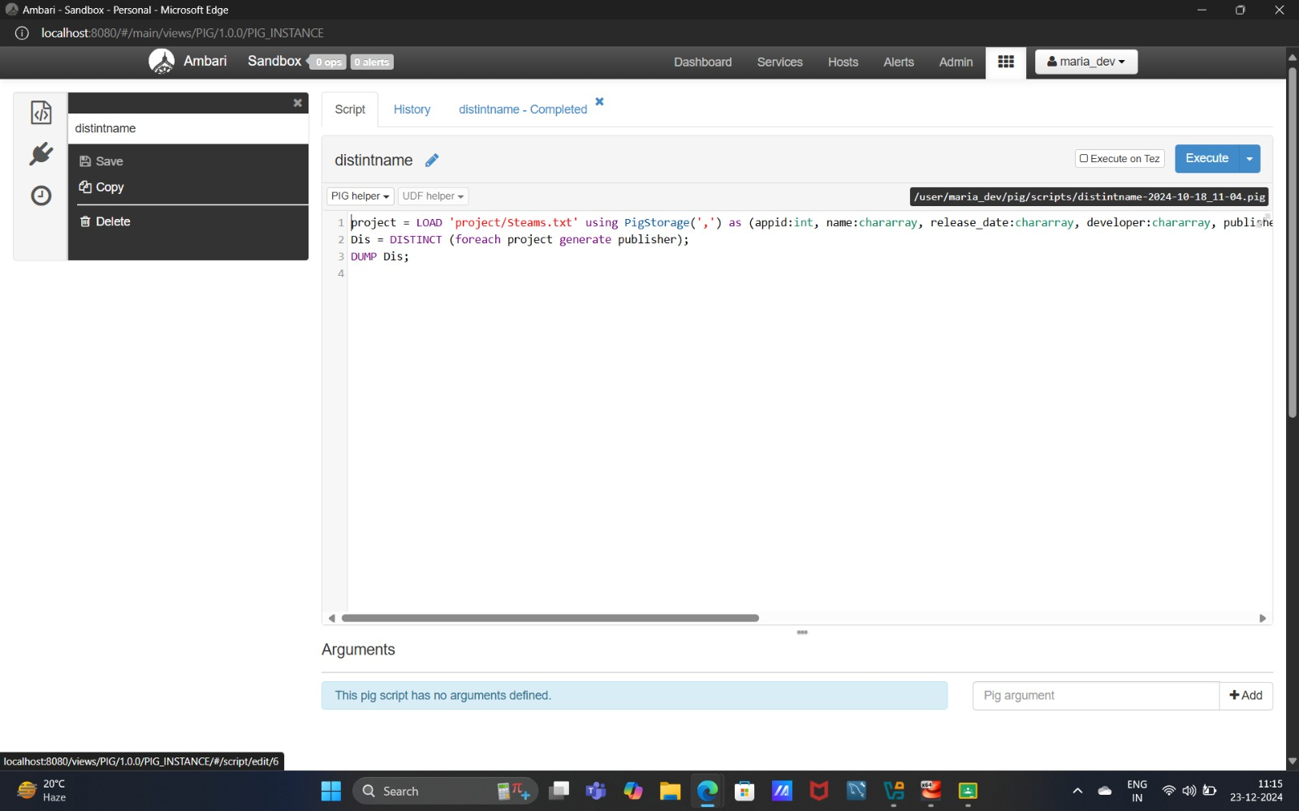

**Output**

**Retrieve sum of price as total price from steam.**

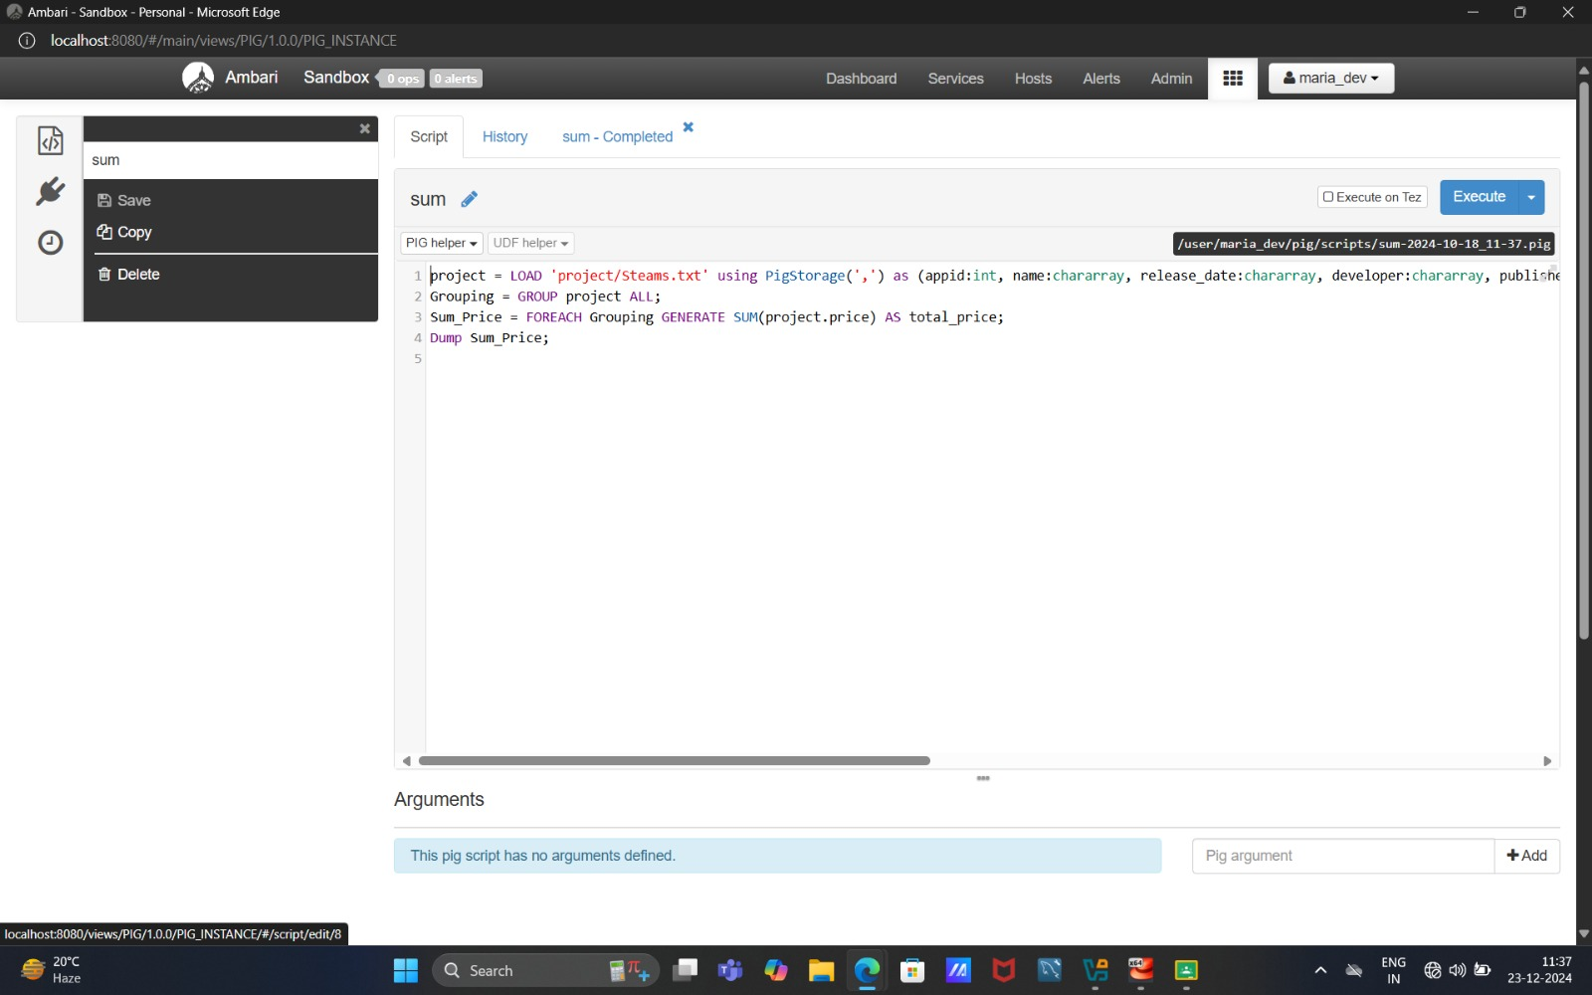**Ans: Input**

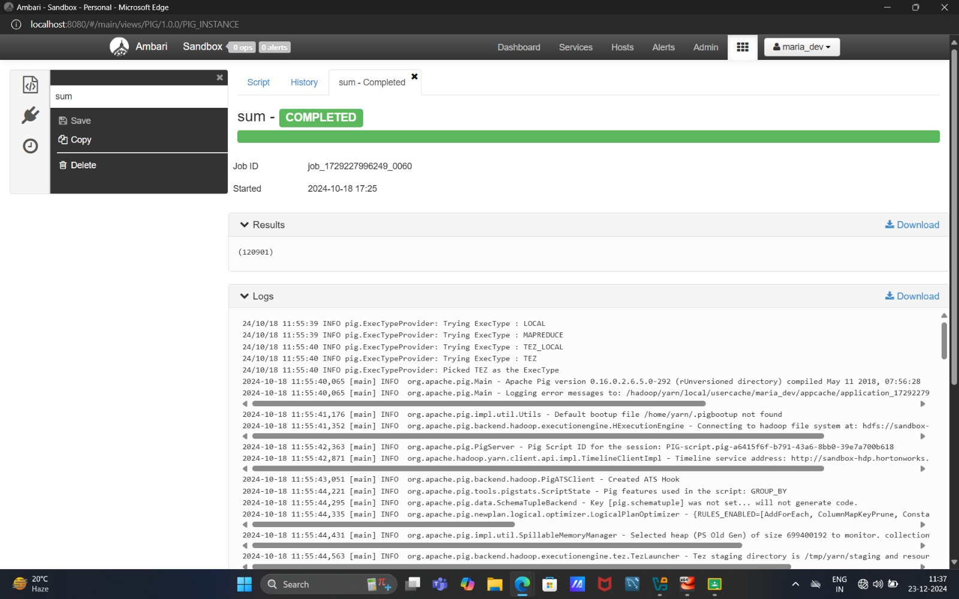

**Output**

**Retrieve all data from this table steam.**

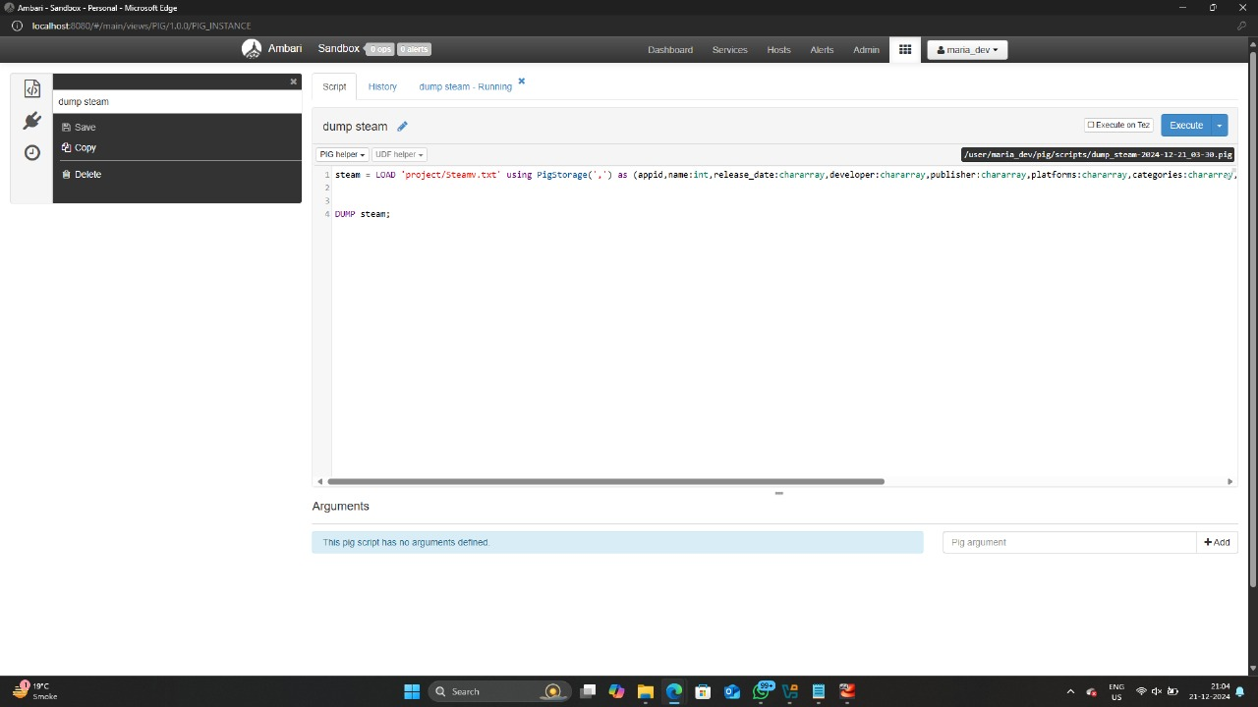**Ans: Input**

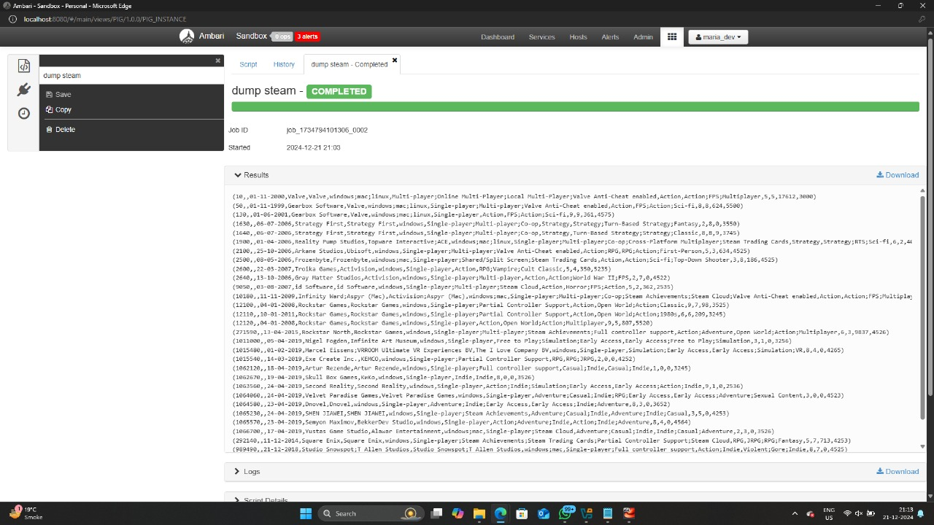 **Output**

**Retrieve Join this table in steam and steam Requirement.**

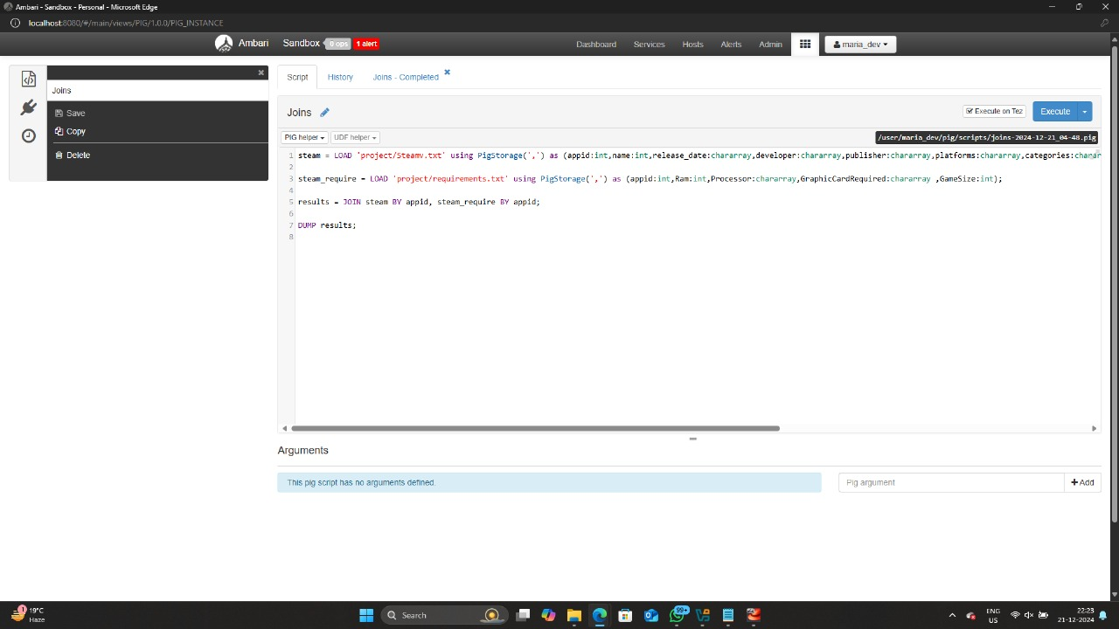**Ans: Input**

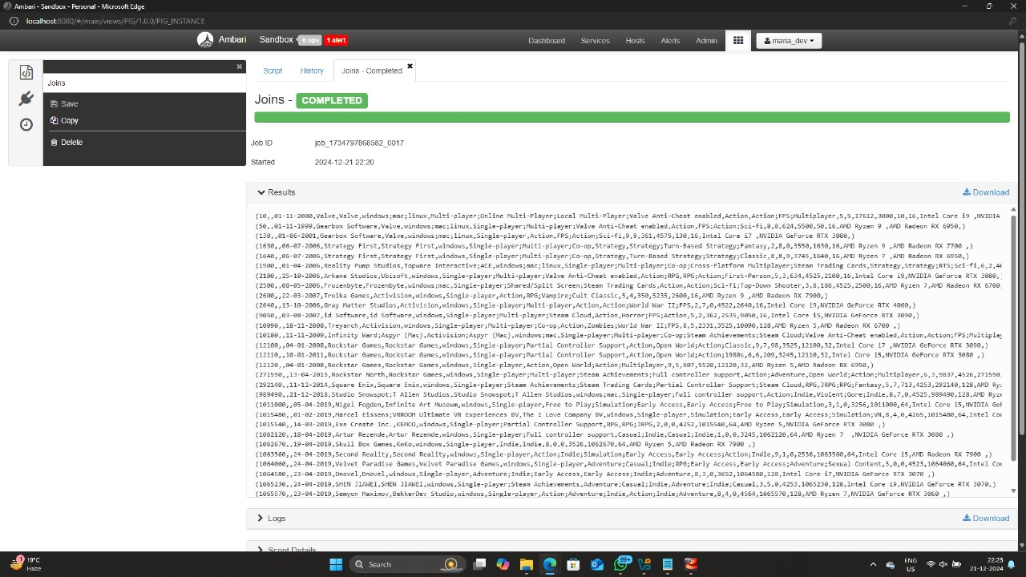**Output**

**Retrieve the data were positive _ratings are greater than 5.**

**Ans: Input**

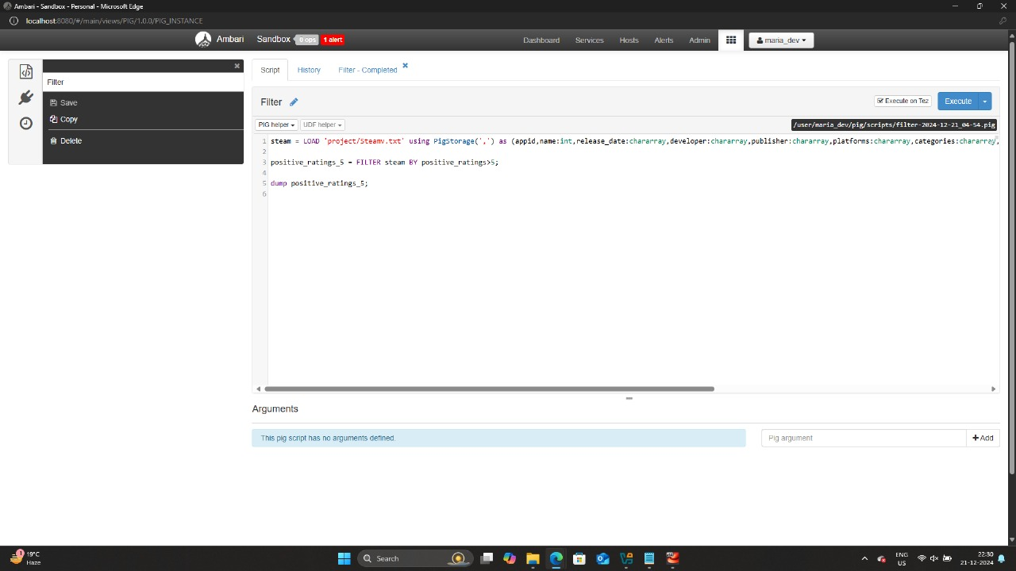

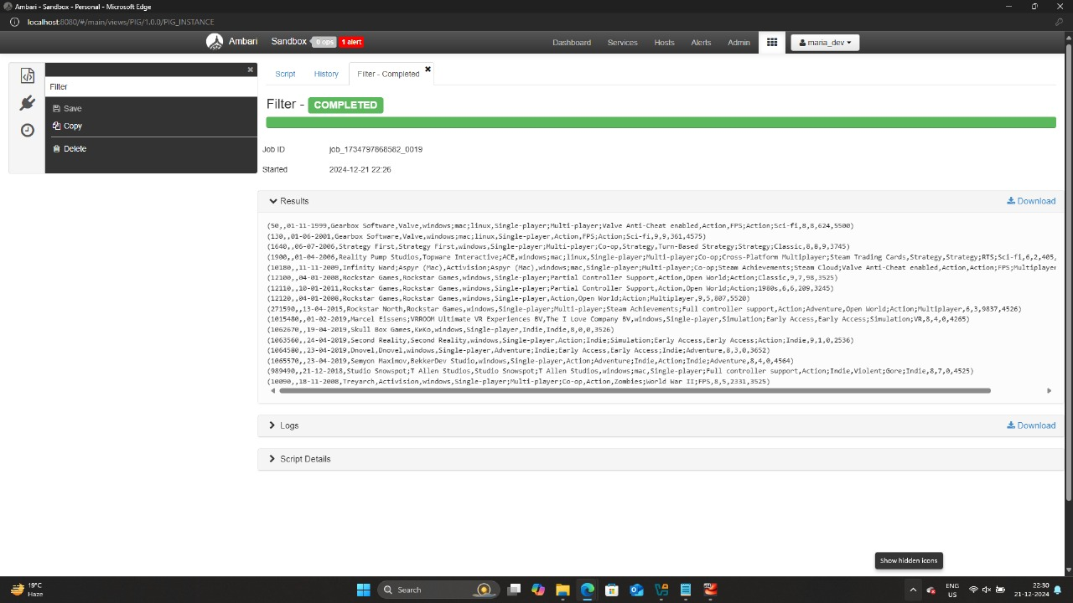**Output**

**Retrieve the data from where price is greater than 4000.**

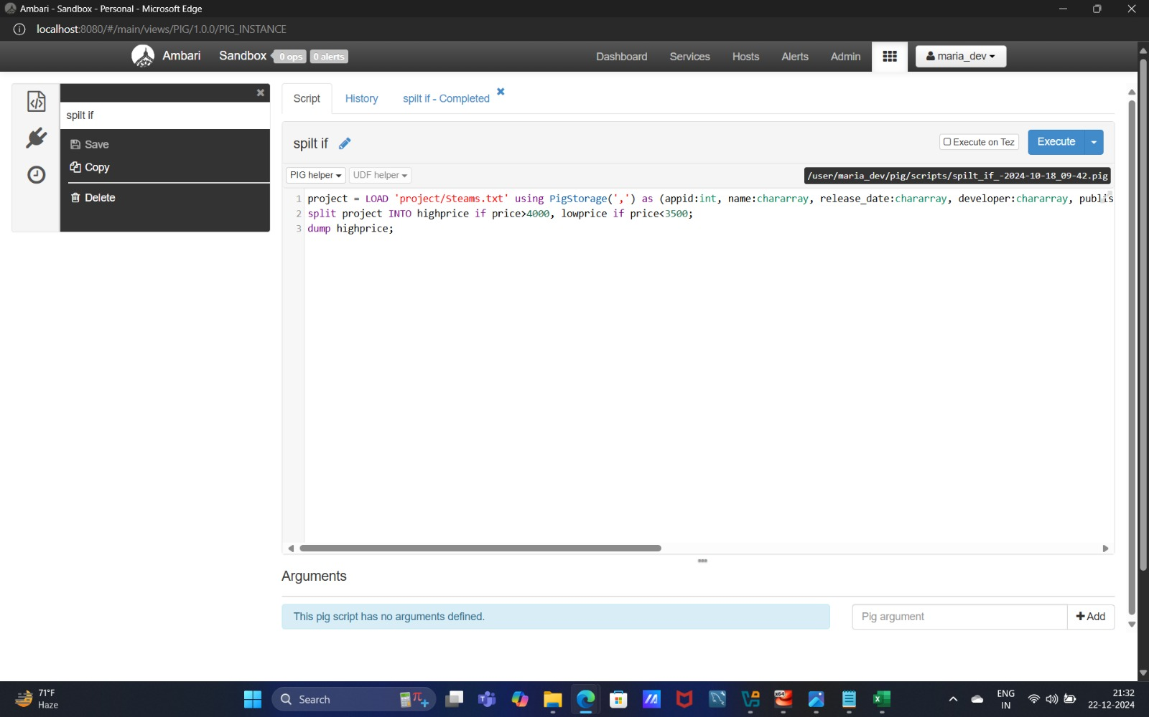**Ans: Input**

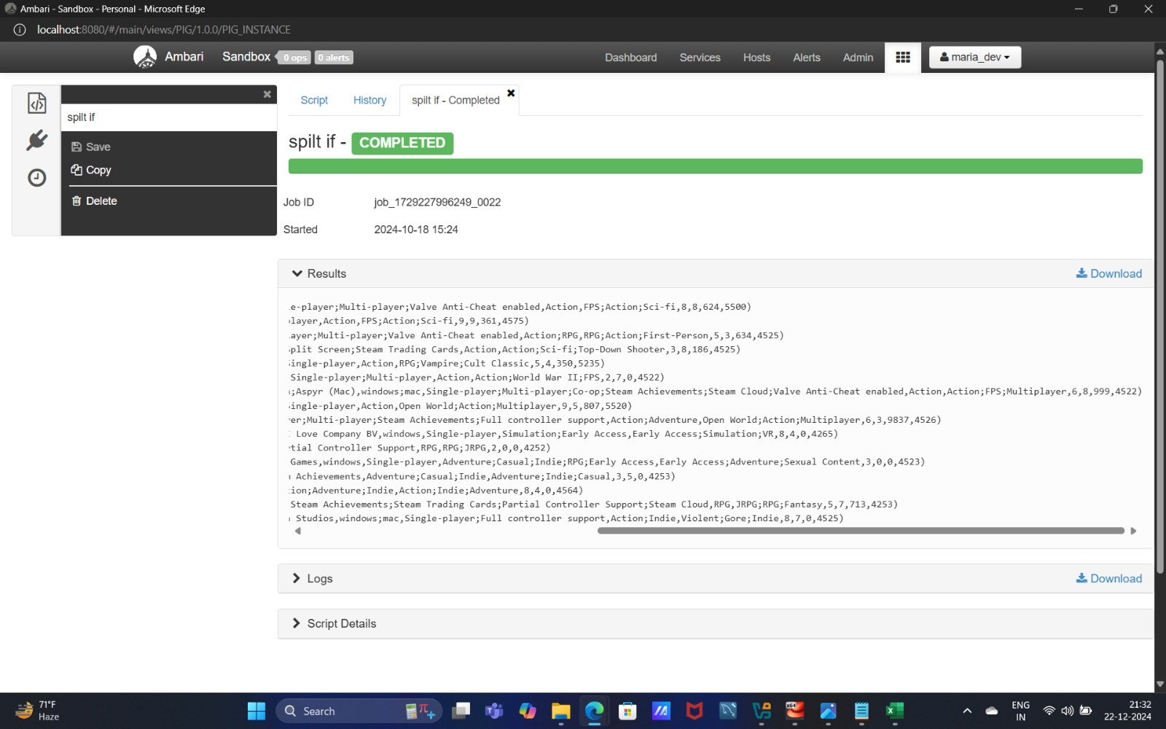**Output**

**Describe the all title from steam table.**

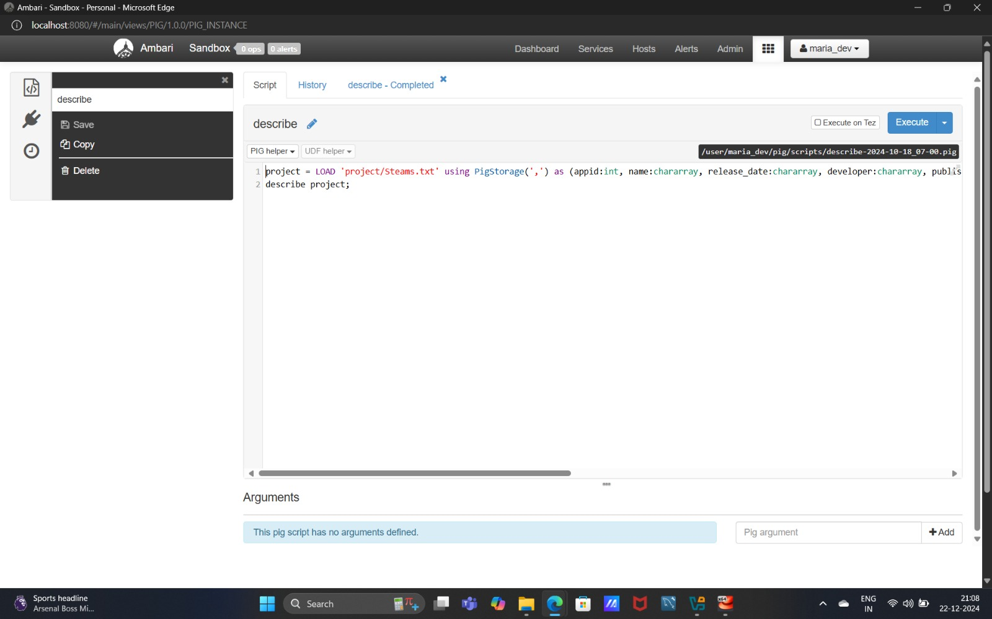**Ans: Input**

**Output**

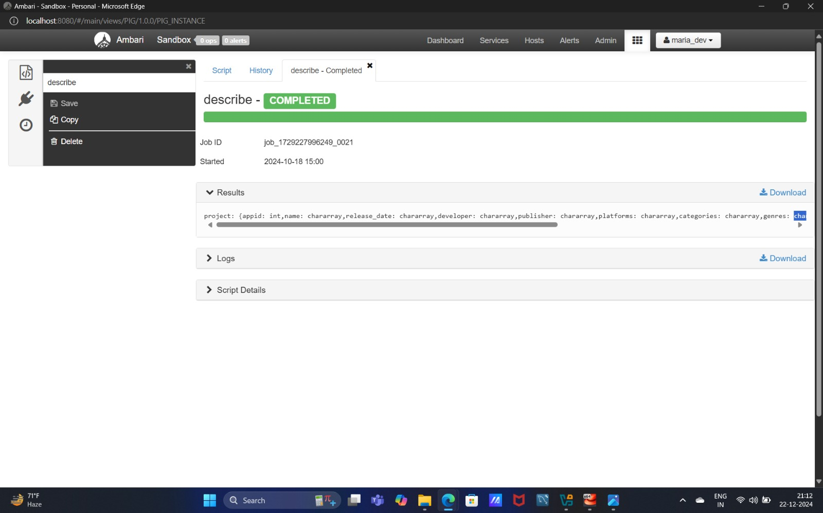

**Retrieve LIMIT , The result will contain only 10 records from the total dataset.**

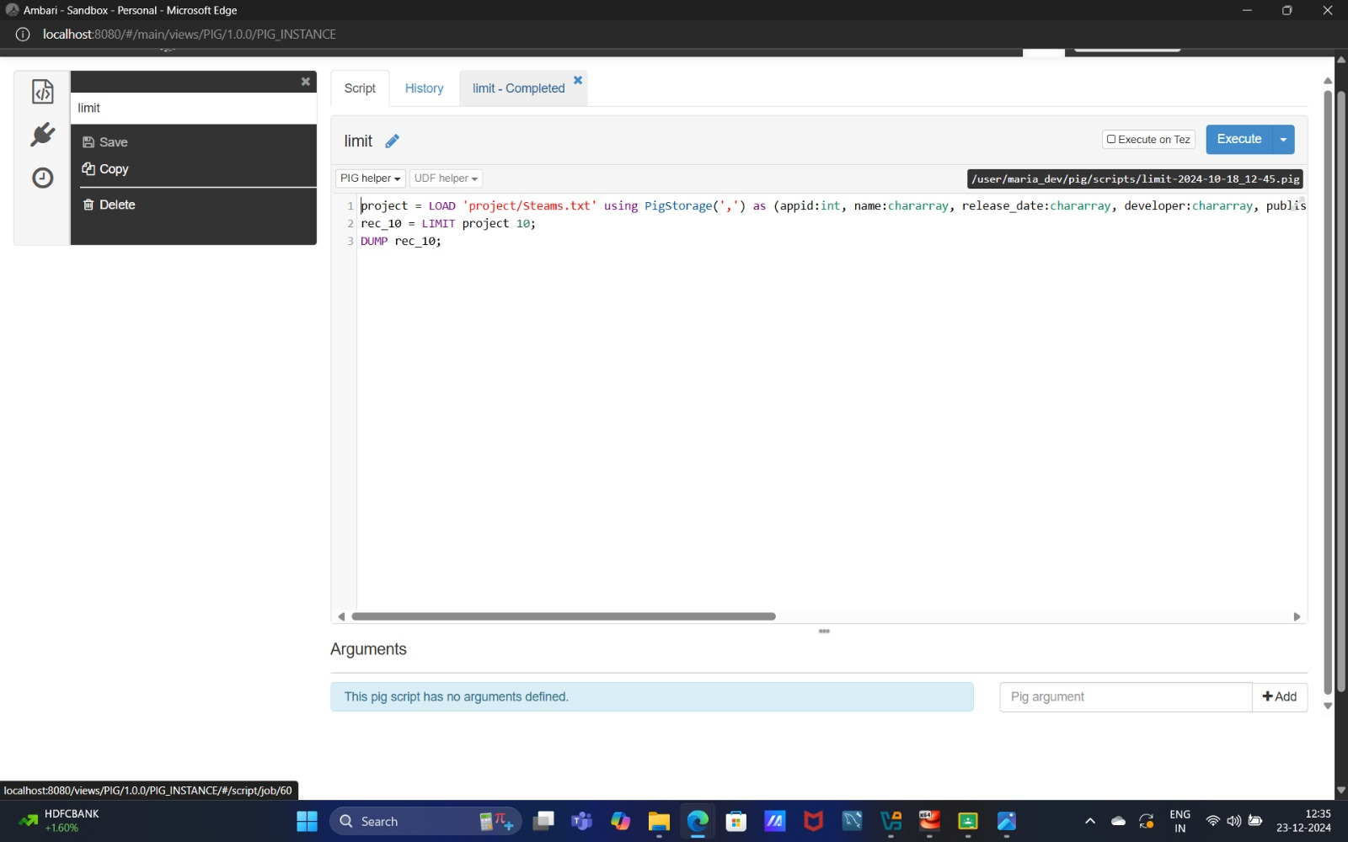**Ans: Input**

**Output**

**Retrieve ORDER by= This operation arranges or sorts the records in the dataset by the name field (likely the project name).**

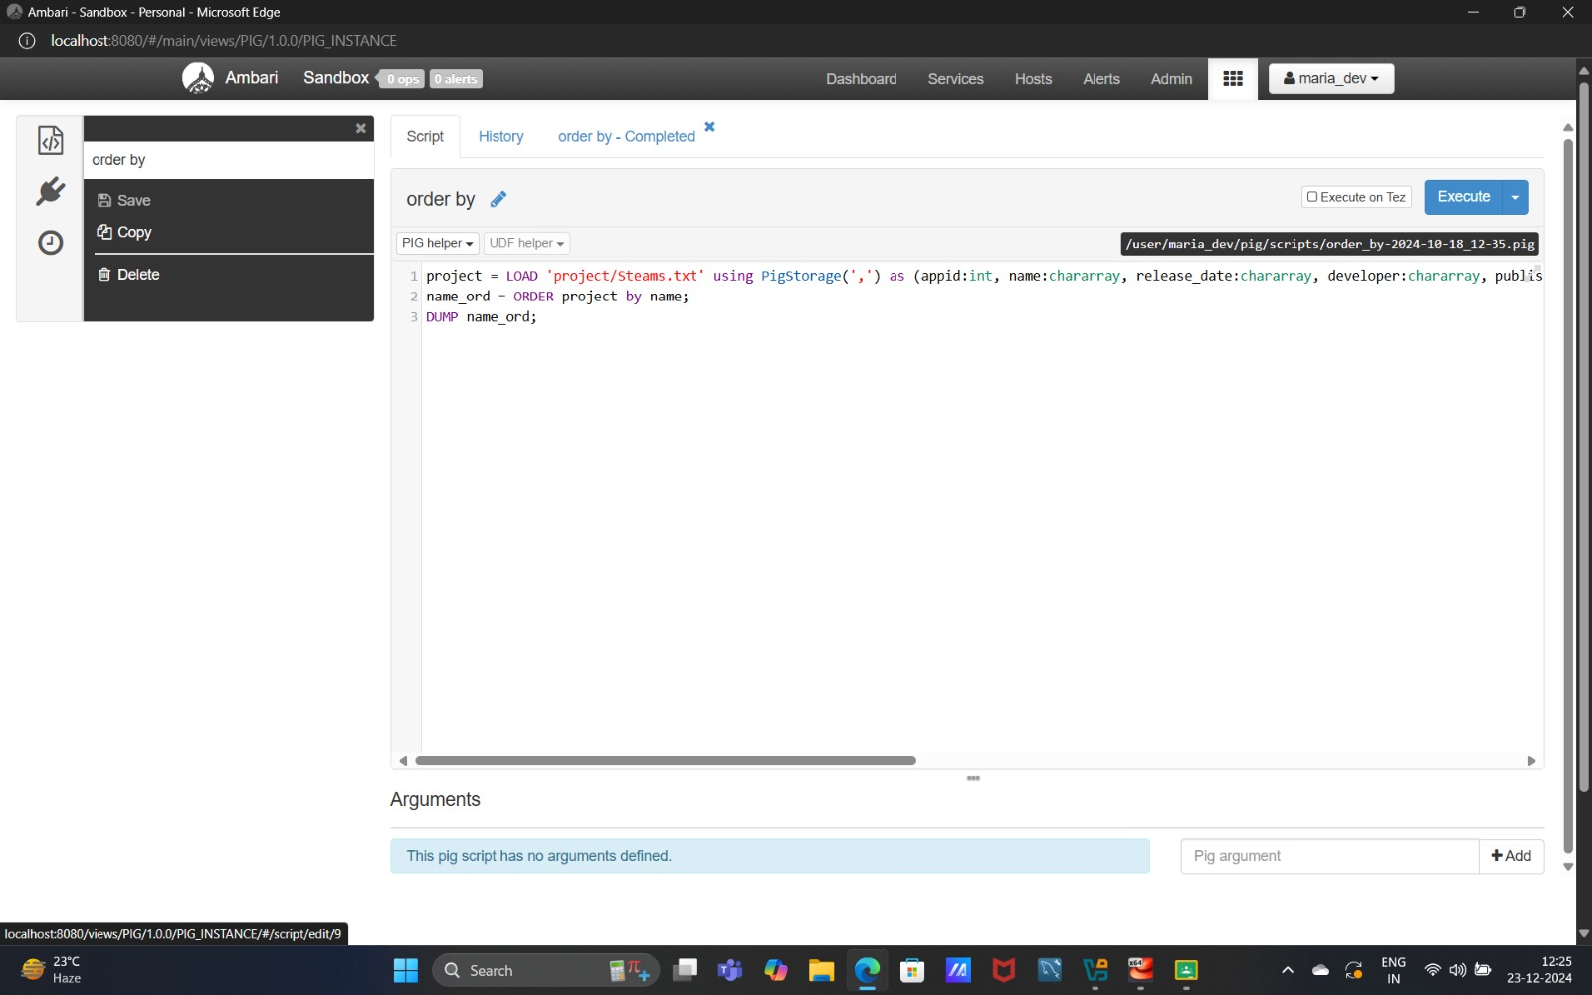**Ans: Input**

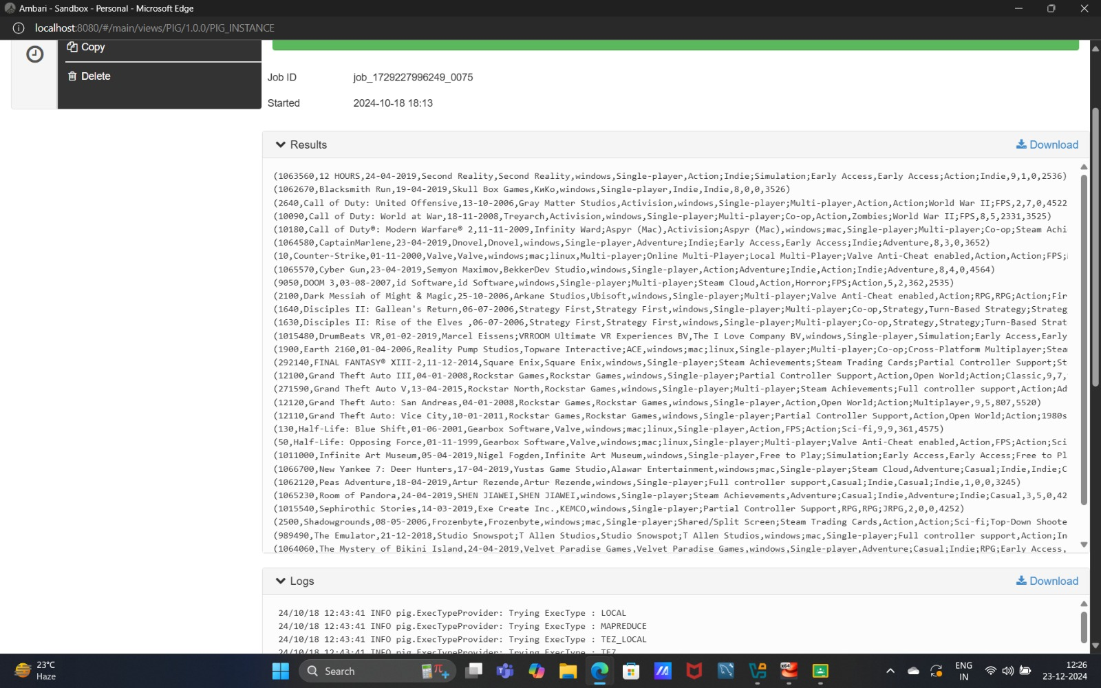**Output**

**Retrieve the data group by publisher.**

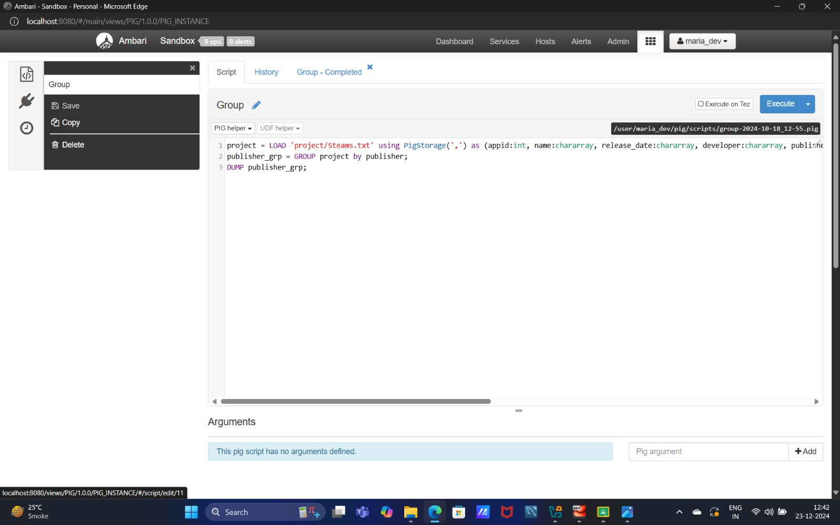**Ans: Input**

**Output**

